INHALATIONAL AGENTS | Des | Iso | Hal | En | Sevo | 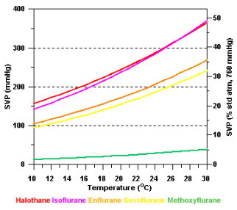
Boiling point (oC) | 23.5 | 49 | 50 | 56 | 58.5
Molecular weight | 168 | 184 | 197 | 184 | 200
SVP (kPa) at 20degC | 89 | 32 | 32 | 23 | 21
% Biotransformation | <0.1 | 0.2 | 20 | 2 | 3 to 5
Blood / gas | 0.42 | 1.4 | 2.5 | 1.9 | 0.69
Oil / gas | 28 | 98 | 224 | 98.5 | 47
MAC in 100% O₂ | 6 | 1.15 | 0.75 | 1.7 | 2
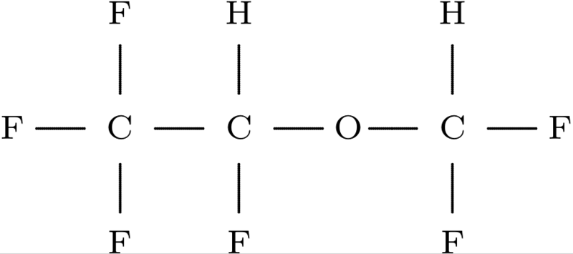
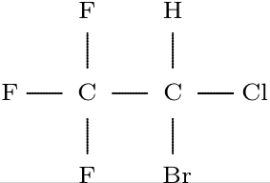
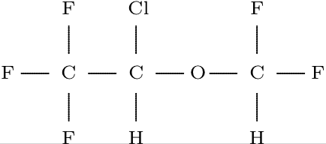
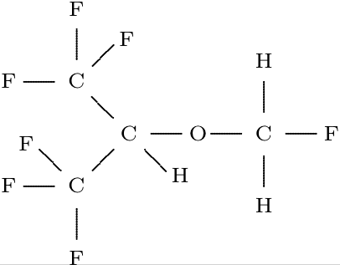

GASES | Atomic | MW | Boiling | Critical | SVP @20ºC
Nitrogen | ¹⁴N | N₂=28 | -195 | -147 | -
Oxygen | ¹⁶O | O₂=32 | -183 | -118 | -
Carbon Dioxide | ¹²C¹⁶O₂ | CO₂=44 | -79 | 31 | 57bar
Nitrous Oxide | ¹⁴N₂¹⁶O | N₂0=44 | -88 | 36.5 | 51bar
Entonox |  |  | Pseudocritical Temp @ 137bar | -7
 |  |  | Pseudocritical Temp @ 117bar | -5.5
 |  |  | Pseudocritical Temp @ 4bar | -30

OPIOIDS | t_{1/2} elim (min) | V_{D} | Cl (ml/min/kg) | Prot Bind | pK_{a} | % ionised (at 7.4) | Rel. lipid sol.
Remifentanil | 10 | 0.3 | 40 | 70% | 7.1 | 32% | 20
Alfentanil | 100 | 0.6 | 6 | 90% | 6.5 | 11% | 90
Morphine | 170 | 3.5 | 16 | 35% | 8 | 77% | 1
Fentanyl | 190 | 4 | 13 | 83% | 8.4 | 91% | 600
Pethidine | 210 | 4 | 12 | 60% | 8.7 | 95% | 30

 | PROCAINE | PRILOCAINE | LIDOCAINE | ROPIVACAINE | BUPIVACAINE | 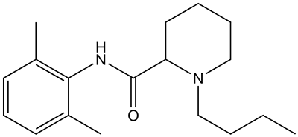  BUPIVACAINE
potency | 1 | 2 | 2 | 8 | 8
Relative Lipid Sol | 1 | 50 | 150 | 300 | 1000
pKa |  | 7.7 | 7.9 | 8.1 | 8.1
% ionised at 7.4 |  | 66% | 75% | 85% | 85%
onset |  | fast | fast | medium | medium
Prot. Bound | 6 | 55 | 70 | 94 | 95
duration | short | medium | medium | long | long
t1/2 elim. |  | 100 | 100 | 120 | 160
